--CREATING TABLE

CREATE TABLE IF NOT EXISTS Titanic(id int,sur int,pclass int,name string,sex string,age int,sibsp int,parch int,ticket string,fare float,cabin string,embarked string)

ROW FORMAT DELIMITED

FIELDS TERMINATED BY ','

STORED AS TEXTFILE;

--LOADING DATA

LOAD DATA LOCAL INPATH '/home/acadgild/Downloads/TitanicData.txt' INTO TABLE Titanic;

QUERY 1:

--Average age of male and female persons died in the titanic tragedy

SELECT SEX,ROUND(COUNT(\*)/SUM(COUNT(\*)) OVER (),2) AS AVG FROM Titanic WHERE SUR=1 GROUP BY sex ORDER BY sex;



QUERY 2:

---Number of people died and survived in each class

--People survived in each class.

SELECT pclass,COUNT(sur) FROM Titanic WHERE sur==0 GROUP BY pclass;

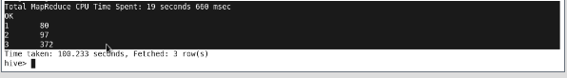

--People died in each class.

SELECT pclass,COUNT(sur) FROM Titanic WHERE sur==1 GROUP BY pclass;

